1. How to find B? ANS: treat B as DPF

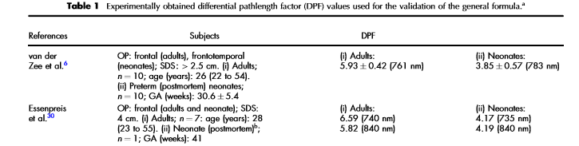

1. unit of intensity in the raw data

ANS: doesn’t matter

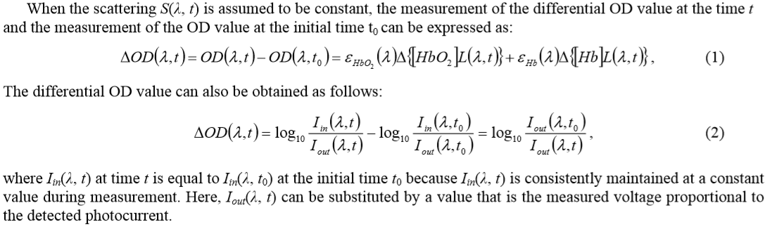

(Iout(t0) is an average of the first 10 data)

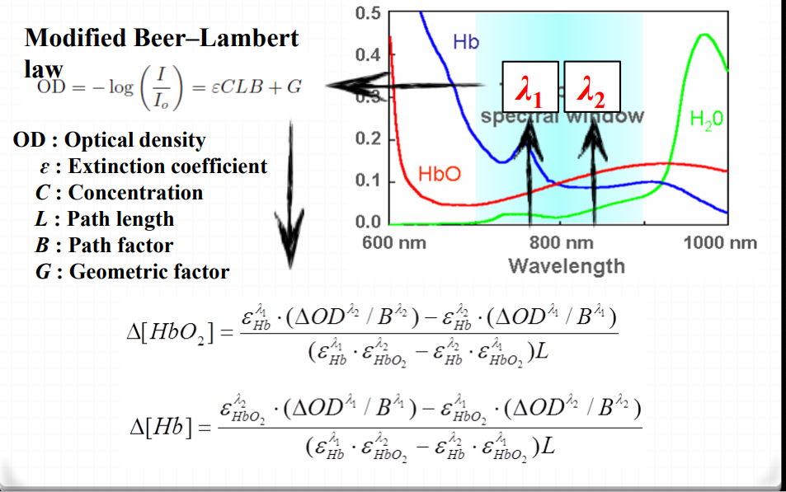

1. why matrix rather than the above formula?

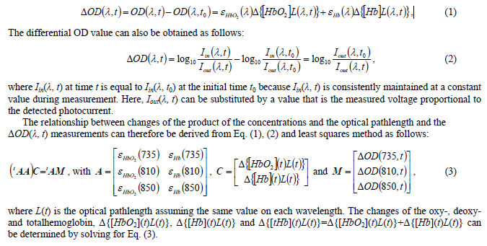

5.What additional function can be added besides plotting?

ANS: TOI